2.0 Text Classification Modal Building
This section will be focusing on developing a text classification model for analyzing food delivery app reviews. The goal is to automatically categorize customer feedback into three sentiment categories, which is positive, neutral, and negative based on the textual content of a review. This type of sentiment analysis is widely used in customer-facing industries to help understand user satisfaction and identify for company on its areas of improvement.

Problem Statement
Food delivery platforms receive various numbers of user reviews every day, which by using manual inspection is inefficient, inconsistent, and very time-consuming. Hence, with the help of text classification, sentiment classification can provide an automated way to interpret customer opinions at scale of:
- Assess customer satisfaction and identify pain points in their services.
- Detect issues or complaints in real-time and etc. This approach helps to enables businesses to efficiently analyze customer feedback.
- Gain actionable insights into overall user sentiment toward their platform.
- Track performance over time by monitoring sentiment trends after app updates or marketing campaigns.

2.1 Dataset and Exploratory Data Analysis (EDA)
2.1.1 Literature Review

2.1.2 Exploratory Data Analysis (EDA)
Dataset Overview
The dataset used in this modal consists of user reviews which is collected from multiple food delivery applications. This dataset was obtained from Mendeley and contains a total of 1,694,581 records with 14 variables. The dataset variables are including content reviews, user ratings, sentiment indicators, and several other fields.

Key Variables
Variables | Data Types | Description
Content | Nominal | The full text of the user review.
Score | Ordinal | The star rating given by the user (1-5).
thumbsUp | Ratio | The number of likes (thumbs up) a review received.
Apps | Nominal | The app to which the review belongs (DoorDash, Grubhub, or Uber Eats).
sentiment | Ordinal | The sentiment category assigned based on the star rating (Positive, Neutral, Negative).
afinn_score | Interval | Sentiment score based on the AFINN lexicon (higher values indicate positive sentiment, lower values indicate negative sentiment).
vader_neg | Interval | Negative sentiment score assigned by VADER (closer to 1 indicates stronger negativity).
vader_neu | Interval | Neutral sentiment score assigned by VADER (closer to 1 indicates a more neutral review).
vader_pos | Interval | Positive sentiment score assigned by VADER (closer to 1 indicates stronger positivity).
vader_compound | Interval | Overall sentiment score from VADER.
word_count | Ratio | The total number of words in the review.
Ease_of_Use | Ordinal | A value indicating whether the review contains keywords related to perceived ease of use (1 = present and positive, -1 = present and negative, 0 = absent).
Intention_to_Use | Ordinal | A value indicating whether the review contains keywords related to perceived intention to use the app (1 = present and positive, -1 = present and negative, 0 = absent).
Usefulness | Ordinal | A value indicating whether the review contains keywords related to perceived usefulness of the app (1 = present and positive, -1 = present and negative, 0 = absent).

Key Distribution Analysis
content (Text Preprocessing & Noise Removal Required)
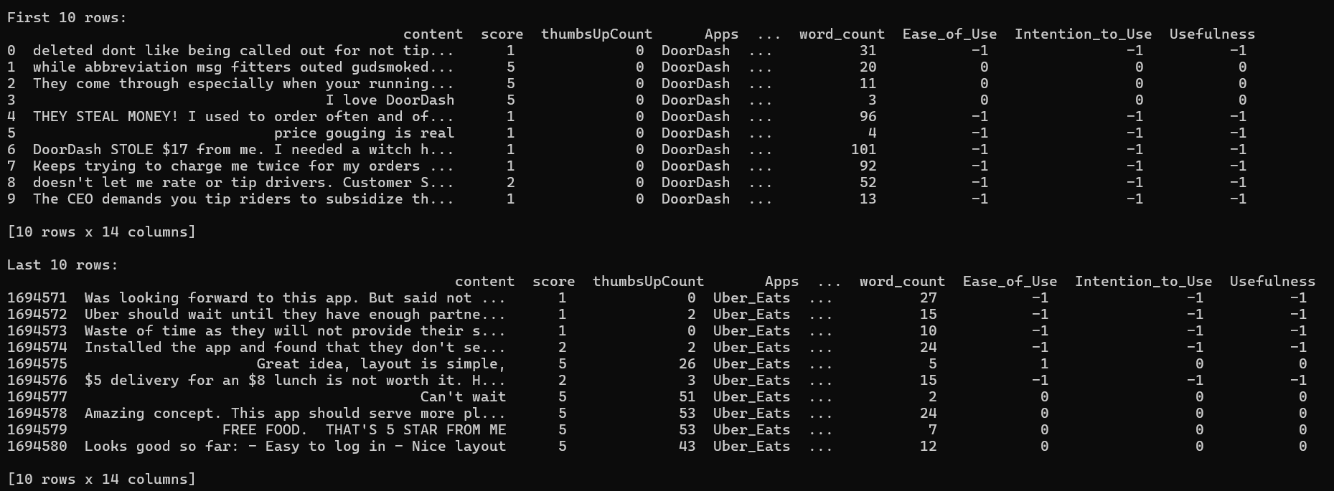
An examination of the content variable revealed that the review texts vary widely in length. Having a large portion of the reviews means that there is high probability of having a very short text, which often consisting of only a few words or brief comments such as “na”, “ok” or “#good”. These short reviews provide limited information and may reduce the effectiveness of sentiment analysis models.

This uneven distribution highlights the importance of text preprocessing and noise removal. Very short or uninformative reviews may need to be filtered out or treated differently to avoid negatively affecting the accuracy of the predictive models.

Sentiment (Data sampling required)

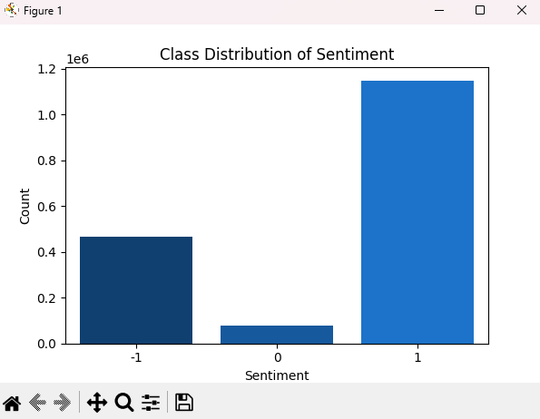
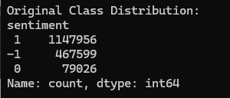
The dataset displays a highly imbalanced sentiment distribution. Most reviews fall into the positive category, reflecting generally favorable experiences with food delivery services. A smaller portion of reviews are negative, while neutral reviews represent the smallest group.
This imbalance is important because machine learning models naturally tend to favor the majority class. Without addressing this issue, a sentiment classifier might overpredict positive sentiment and underrepresent negative or neutral opinions. By recognizing this imbalance during EDA can help to guided the decision to use undersampling during preprocessing to ensure that all three sentiment categories contribute equally to the training process.

Missing Value Analysis
# Invalid strings
invalid_strings = ['nan', 'n/a', 'na', '', 'none', 'null']
# Check for missing values
df_check = df_lower.copy()
for col in df_check.select_dtypes(include=['object']).columns:
df_check[col] = df_check[col].str.strip().str.lower()
df_check = df_check.replace(invalid_strings, np.nan)
missing_rows = df_check[df_check.isnull().any(axis=1)]
print("\nMissing values per column:\n", df_check.isnull().sum())
print("\nSample rows with missing values:\n", missing_rows.head())

Missing values in the dataset were identified and must be handled to ensure data quality. A list of invalid strings that may indicate missing data was defined to ensure that all text columns were standardized by stripping leading and trailing whitespace and converting to lowercase.
From the codes above, the author will perform for loop to check any occurrence of the invalid strings. If it is found, it will be replaced with NaN, which will be easier to recognize that it is a missing value, and also will be added to the counter to indicate that the content value is missing.

Rows containing missing values must dropped, as including them could provide incorrect or incomplete information to model during training, which may reduce model performance or introduce bias.

Output
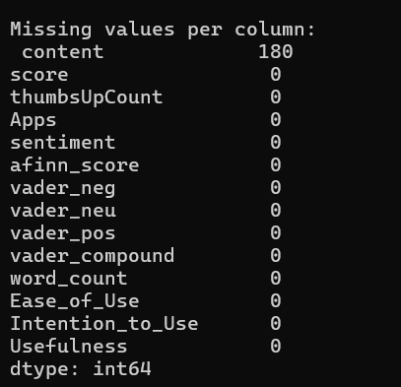
There are around 180 missing values on content column, which mainly was empty reviews.

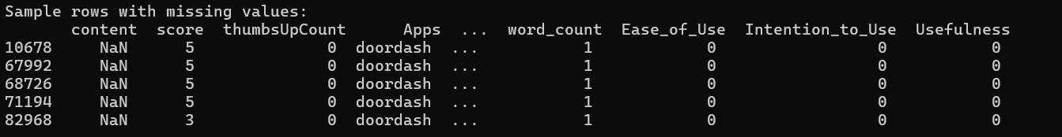
Duplicate Analysis
# Check for duplicate content
print("\nDuplicate content rows:", df_lower['content'].duplicated().sum())

A duplicate analysis was performed on the ‘content’ column to determine whether the dataset contained repeated reviews. The results showed a large number of duplicate entries, with 508,736 reviews appearing more than once. These duplicates likely originated from repeated user submissions, mirrored reviews across platforms, or system-level logging redundancies.
With the help of .duplicated().sum() commands, it can identify on how many rows in the dataset are repeated. The results will indicate that the dataset contained duplicate rows, which means it is repeated observations. Since duplicates can affect the accuracy of the analysis, these rows were identified and removed during the data preprocessing.

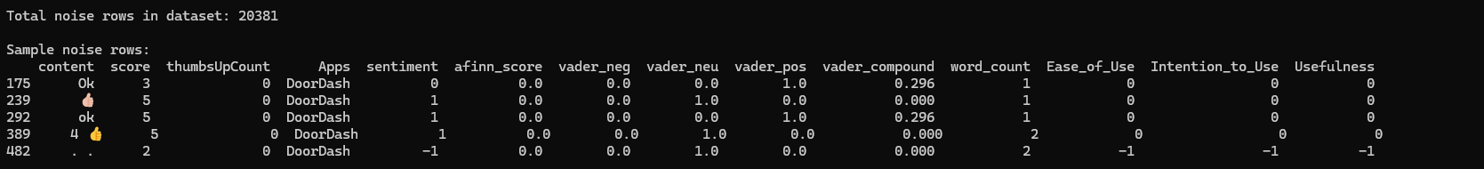
Noise Findings
During the exploratory data analysis, the texts from the content column were examined to identify noise, which refers to entries that do not provide meaningful information for sentiment analysis. Several patterns of noise were detected such as
- Text length that is equal or less than 2.
- Numbers, decimals, percentages.
- Date, Time
- Non-characters
These noisy entries can mislead machine learning models by introducing meaningless patterns or empty information. For instance, numeric-only texts or very short strings do not convey sentiment and may bias the model toward incorrect predictions. To ensure high-quality inputs, all rows matching any of these noise patterns were flagged and removed during preprocessing.
From the image above, a total of 20,381 noisy rows were detected, which mainly consisting of text length is not more then 3 or non-characters text only.
2.1.4 Data Preprocessing
After completing EDA, it was found that the dataset contains inconsistencies and noise. To ensure that the data is clean and suitable for analysis, data preprocessing is a must to performed and should be followed step by step to ensure the data cleanliness.
- Remove noises
In order to clean the dataset, the author first implemented a noise detection process to identify irrelevant or misleading content in the Content column. Noise can include numeric values, timestamps, percentages, dates, short text, or other meaningless entries that do not contribute to analysis.
Noise Pattern Detection
# Pattern for noise detection
time_pattern = re.compile(r'^\s*\d{1,2}:\d{2}(:\d{2})?\s*([ap]\.?m\.?)?\s*$', re.IGNORECASE)
date_pattern = re.compile(r'^(\d{1,2}[/\-]\d{1,2}([/\-]\d{2,4})?|\d{1,2}-\w{3,9}|\d{1,2}\s\w{3,9}\s\d{2,4})$', re.IGNORECASE)
percentage_pattern = re.compile(r'^\s*\d+(\.\d+)?\s*%\s*$', re.IGNORECASE)
numeric_like_pattern = re.compile(r'^\s*[+-]?\d+([.,]\d+)?\s*$', re.IGNORECASE)

# Noise detection
def is_noise_content(text):
text = '' if pd.isna(text) else str(text).strip().lower()
if len(text) <= 2:
return True
if numeric_like_pattern.match(text):
return True
if percentage_pattern.match(text):
return True
if time_pattern.match(text):
return True
if date_pattern.match(text):
return True
letters_only = re.sub(r'[^a-zA-Z]', '', text)
if len(letters_only) <= 2:
return True
if text in invalid_strings:
return True
stripped = re.sub(r'[^\w]+', '', text)
if len(stripped) == 0:
return True
return False
Code Pattern | Noise Identification | Text Example
len(text) <= 2 | Text length is 2 characters or less | “as”, “!”, “z”
numeric_like_pattern | Detect numbers & decimals | “-123”, ”69.69”
percentage_like_pattern | Detect percentage | “15%”, “83.3%”
time_pattern | Detect time strings | 13:30, 6:30a.m.,  09:34:23 PM
date_pattern | Detect date formats | “12/05/2023”, “30 Nov 2025”, “1-Dec”
len(re.sub(r'[^a-zA-Z]', '', text)) <= 2 | By removing all non-letter, then re-check again if text length remaining is 2 characters or less | “Hi!”, “Ok?”, ”321 go!”
len(stripped = re.sub(r'[^\w]+', '', text)) == 0 | By removing all non-letter, then re-check if the text remains nothing. | “!!!!!!!!!!!!!!”, ”???????”
To identify rows containing noise, a set of code patterns is created which detect irrelevant or meaningless content in the dataset.
After identifying the patterns for noise, all rows meeting any of the noise conditions were marked. These noisy rows were then removed from the dataset, and the number of rows removed was calculated.
# Remove noise
before = df_clean.shape[0]
noise_mask = df_clean['content'].apply(is_noise_content)
df_clean = df_clean[~noise_mask].reset_index(drop=True)
removed_noise = before - df_clean.shape[0]
print(f"Noise rows removed: {removed_noise}")
Results
Total of 20,381 rows of noises are removed.
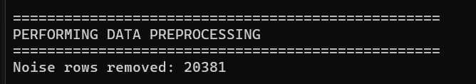

- Perform Text Preprocessing
After removing noise, the dataset still requires text preprocessing to handle special text patterns and prepare it for analysis. This process will standardize the text, remove irrelevant content, and normalize words.
Text Preprocessing Syntax
# Full text preprocessing
def text_preprocess(doc):
temp = '' if pd.isna(doc) else str(doc).lower() # Lowercase
temp = re.sub("@[A-Za-z0-9_]+", "", temp) # Remove mentions
temp = re.sub("#[A-Za-z0-9_]+", "", temp) # Remove hashtags
temp = re.sub(r"http\S+|www\.\S+", "", temp) # Remove URLs
temp = re.sub("[0-9]+", "", temp) # Remove numbers
temp = re.sub("'", " ", temp) # Replace apostrophes with spaces
temp = temp.strip() # Trim whitespace
if len(temp) == 0:
return ""
tokens = word_tokenize(temp)
tokens = [reduce_lengthening(w) for w in tokens] # Reduce repeated characters
tokens = [lemm.lemmatize(w) for w in tokens] # Lemmatize words
tokens = [w for w in tokens if len(w) > 2] # Remove short tokens
return " ".join(tokens)

# Apply full text preprocessing
print("\nApplying text preprocessing...")
df_clean['content'] = df_clean['content'].progress_apply(text_preprocess)
The syntax above performs preprocessing on the Content column by cleaning and normalizing the text. Unlike general noise, which targets short or meaningless entries, these patterns specifically remove structured but irrelevant text, such as URLs, mentions, hashtags, numbers, or excessive punctuation. This ensures that both meaningless and syntactically irrelevant entries are eliminated, making the dataset ready for accurate model training.

Code Pattern | Text Identification & Results | Text Example
if pd.isna(doc) else str(doc).lower() | Check if the text is NaN  True: Lowercase all text  False: return empty string
re.sub("@[A-Za-z0-9_]+", "", temp) | Remove mentions | “@elon_musk”, “@Mark76”
re.sub("#[A-Za-z0-9_]+", "", temp) | Remove hashtags | “#Uber_Eats”
re.sub(r"http\S+|www\.\S+", "", temp) | Remove URL | “https://www.google.com”
re.sub("[0-9]+", "", temp) | Remove all numbers | “Rate 100” => “Rate ”
re.sub("'", " ", temp) | Replace apostrophes to space | “Doesn’t” => “does t”
temp = temp.strip() # Trim whitespace  if len(temp) == 0:  return "" | Trim whitespace | “does t “ => “doest”
[reduce_lengthening(w) for w in tokens] | Reduces repeated characters in words (Tokenized) | “okkkkkkkk” => “okk”
[lemm.lemmatize(w) for w in tokens] | Lemmatization (Tokenized) | “running” => “run”
[w for w in tokens if len(w) > 2] | Removes very short words (2 letters or less (Tokenized) | ["I", "eat", "an", "apple"] => ["eat", "apple"]

- Duplicate content removal
# Remove duplicates
before = df_clean.shape[0]
df_clean = df_clean.drop_duplicates(subset=['content']).reset_index(drop=True)
removed_duplicates_after = before - df_clean.shape[0]
print(f"Duplicate content rows removed after text preprocessing: {removed_duplicates_after}")
After checking for noise and performing text preprocessing, the author finally can perform duplicate content removal, as this is because previous process will have required standardizes the text, as after performed it will making more easier to identify exact or near-exact duplicates that might have been missed in raw form.
Results
Total of 571,230 rows of duplicated content are removed.

- Remove NaN related empty rows
# Remove NaN/empty rows
before = df_clean.shape[0]
df_clean = df_clean.replace(invalid_strings, np.nan).dropna()
removed_nan = before - df_clean.shape[0]
print(f"\nRows removed due to NaN: {removed_nan}")
This step removes any rows that are empty or contain invalid strings (like empty text), ensuring that the dataset only contains valid content for further analysis.
Results
Total of 2 rows of NaN are removed.


- Data balancing
# Find the minority class size
min_size = df_clean['sentiment'].value_counts().min()
print(f"Minority class size: {min_size}")

# Resample each class to match the minority size
balanced_frames = []
for sentiment_val in [-1, 0, 1]:
df_class = df_clean[df_clean['sentiment'] == sentiment_val]
if not df_class.empty:
df_resampled = df_class.sample(n=min_size, random_state=42)
balanced_frames.append(df_resampled)

# Combine and shuffle
df_balanced = pd.concat(tqdm(balanced_frames)).sample(frac=1, random_state=42).reset_index(drop=True)

The final step of data preprocessing is to perform data balancing. This is required so that each sentiment column class has an equal number of samples, preventing the model from being biased toward majority classes and it will also help improving overall prediction performance. In this data balancing, undersampling method is being used because the dataset is large, and reducing the size of majority classes is more efficient than duplicating minority samples. Undersampling avoids overfitting that can occur with repeated data in oversampling, while keeping the dataset manageable for faster training.
Results
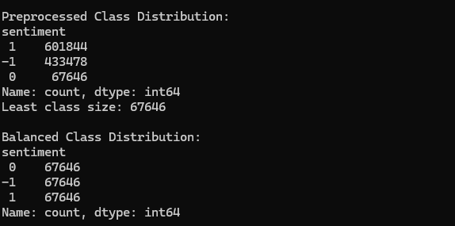

From the image above, the preprocessed original class distribution for the sentiment column was highly imbalanced, in which:
- 1 had the most samples, around 601,844.
- 0 had the fewest samples, with only 67,646.

With the using of undersampling method, each sentiment class now has an equal number of samples, consisting of 67,646 rows for each of 1, 0, and -1. This ensures that the dataset is balanced and prevents the model from being biased toward the majority class during training.

2.1.5 Predictive Machine Learning Model
In order to generate a sentiment analysis modal, predictive models are required to train on the dataset and produce accurate sentiment predictions. Hence, the group suggests several models for this task, which include:
1. Naive Bayes
2. Logistic Regression
3.

To determine which model performs best, the accuracy of each model is calculated. The model with the highest accuracy is considered the most suitable, as it produces the most correct predictions aligned with the users’ expectations.

